GRANARD MUNICIPAL DISTRICT

Corporate Affairs,
Aras an Chontae,
LONGFOIRT.

19th January 2016.

Please note Venue of Meeting – Granard Community Library .

To: Each Member of Granard Municipal District.

Dear Member,

You are requested to attend Meeting of Granard Municipal District to be held in
Granard Community Library on Tuesday, 26th January 2016 at 3.00 p.m. to transact business, as set out on the Agenda hereunder.

Yours sincerely,
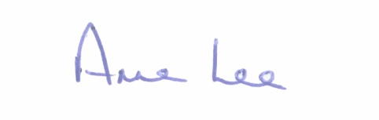

_______________
Anne Lee,
Meetings Administrator.

AGENDA

Prayer before meeting.

1. Confirmation of Minutes of the following Meetings of Granard Municipal District -

- Committee Meeting held on the 24th November 2015.
- Meeting held on the 24th November 2015.
- copies enclosed.

2. Matters arising from Minutes.

3. Presentation on Longford Age Friendly Strategy.

4. Survey of roads and footpaths in Council owned housing estates.

5. Notices of Motions submitted by Councillors, as listed hereunder -

Councillor Luie McEntire.

“That sufficient funding be made available to alleviate the traffic problem at Gaigue Cross in 2016. This is a busy, dangerous crossroads. Hundreds of people have signed a petition to have work carried out at Gaigue Cross.”

Councillor John Duffy.
“That works be carried out at the County Bridge at Drumury, Moyne as recent weather has led to prolonged closure of this important route. I refer to my motion last year to have a low cost safety scheme for this road to be acted on as a matter of urgency and to now include remedial bridge works.”
Councillor P.J. Reilly.

“That the footpath on the Granard – Ballinalee road out to Kiernan Milling be extended as there are two major factories on this road and it is very dangerous for employees walking to work.”

Councillor Pauric Brady.

“That the footpath be extended from Costcutters to the Garda Barracks in Drumlish.”

6. A.O.B.

